University of Maryland, Baltimore County

Note Taking Website

Deliverable 2

Soham Adhikary, Wentao Chen, Kimberly Ho, Kristen Jones, Paul Rajapandi, Catherine Vargas

IS 436 - 01 Class ID: 51029

Professor Shiva Sharma

March 19, 2023

Requirements Definitions

**Functional Requirements**

Process-Oriented

* The system must allow the registered user to retrieve their notes.
* The system should allow users to store notes.
* The system should allow users to label the notes.
* The system should allow users to view the notes that they have stored.
* The system sends an approval request after the user uploads their notes.

Information-Oriented

* The system must retain the user's label and notes permanently.
* The system must include real-time inventory levels.
* The system must include the total number of notes for the current day.
* The website pages should load in 3 seconds with the total number of simultaneous users <500.

**Non-Functional requirements**

Operational

* The system will run on different kinds of end devices.
* The system should be compatible with any Web browser.
* The system should be responsive to the mobile device.
* The system should be able to integrate with the existing inventory system.

Performance

* Any interaction between the user and the system should not exceed 2 seconds.
* The system should be available 24 hours per day, 365 days per year.
* The system supports 100 simultaneous users from 9-11 am; 85 simultaneous users at all other times.

Security

* Only direct managers can see staff personnel records.
* Technicians can see only their own work assignments.
* Only the customers themselves or the ones that are given permissions can view the content of their notes.
* The system includes all available safeguards from viruses, worms, trojan horses, etc.

Cultural/Political

* The system should be able to distinguish between US currency and currency from other nations.
* Country managers are permitted to authorize custom user interfaces within their units
* Personal information is protected in compliance with the data protection act.

Interview Information

Person Interviewed: America Mathews

Position of Interviewee: Student and Employed

Title: Chemistry Major, Retail Worker

Interviewer: Kimberly Ho

Date: 3/12/2023

Time: 12:05:23

Questions Asked:

* Do you prefer to take notes electronically, written, or both? Please explain
* How are you most likely to access electronics notes? Ie. Website, Apps, Laptop or PC, Mobile Device.
* What note taking apps or sites have you used and which one do you like most and why? Ie. Microsoft OneNote, Default Device Notes, Notion, etc
* What is your favorite thing about using those apps or taking notes traditionally?
* What features do you wish were included in note taking applications websites?
* Is there any other feedback you’d like to share?

Purpose of Interview:

* To understand why potential customers use competitor systems
* To understand positive points of current competitor systems
* To learn improvements needed to current note taking systems customers wish were included
* To understand what customers want out of our future system
* To incorporate the positives of both written and electronic notes into a system

Summary of Interview: Interviewee has used previous Note apps such as Mircroft OneNate, Default Device notes, Notion, Evernote, and Simplenote preferring to access these notes on websites, applications, and their mobile device. They feel that taking notes electronically doesn’t waste paper unlike transitional ways of note taking and can be printed if need be. They enjoy being able to easily turn their notes into a PDF with an unlimited word count while also being able to enjoy different pen options and colors. Though do wish that there was an option for custom brushes and an easy to access scribble tool for text, shapes, and math functions. They find that it is okay to charge a monthly subscription for more premium features but dislike those that charge after a certain amount of pages.

Observation Notes:

Competitor Positives: Easy PDF conversion, multiple pen and color options with unlimited word space.

Dislikes: Over excessive Monthly subscriptions

Interviewee is a Chem student who mentioned wanting custom brushes like hexagons for chem. Create an easier to access scribble to text tool tool for math functions, shapes, and words.

Person Interviewed: Sarah Prasons

Position of Interviewee: Employed

Title: IT Specialist

Interviewer: Kimberly Ho

Date: 3/13/2023

Time: 10:56:26

Questions Asked:

* Do you prefer to take notes electronically, written, or both? Please explain
* How are you most likely to access electronics notes? Ie. Website, Apps, Laptop or PC, Mobile Device.
* What note taking apps or sites have you used and which one do you like most and why? Ie. Microsoft OneNote, Default Device Notes, Notion, etc
* What is your favorite thing about using those apps or taking notes traditionally?
* What features do you wish were included in note taking applications websites?
* Is there any other feedback you’d like to share?

Purpose of Interview:

* To understand why potential customers use competitor systems
* To understand positive points of current competitor systems
* To learn improvements needed to current note taking systems customers wish were included
* To understand what customers want out of our future system
* To incorporate the positives of both written and electronic notes into a system

Summary of Interview:

Interviewee has used previous Note apps such as Mircroft OneNate, Default Device notes, however preferring written notes with general pen feel and an increase in memorization. Company provides Microsoft accounts allowing coworkers to easily share notes and everything is kept in one spot. They expressed interest in a program that would more easily create graphs and include rulers, protractors, and a calculator.

Observation Notes:

Competitor Positives: Easy to access and able to come back to in the future with the additional bonus of creating graphs

Interviewee has expressed interest in a service that can be used to more easily create graphs, including rulers, protractors, and calculators.

Person Interviewed: Jamiya Lindsey

Position of Interviewee: Employed

Title: English Teacher

Interviewer: Kimberly Ho

Date: 3/14/2023

Time: 19:23:54

Questions Asked:

* Do you prefer to take notes electronically, written, or both? Please explain
* How are you most likely to access electronics notes? Ie. Website, Apps, Laptop or PC, Mobile Device.
* What note taking apps or sites have you used and which one do you like most and why? Ie. Microsoft OneNote, Default Device Notes, Notion, etc
* What is your favorite thing about using those apps or taking notes traditionally?
* What features do you wish were included in note taking applications websites?
* Is there any other feedback you’d like to share?

Purpose of Interview:

* To understand why potential customers use competitor systems
* To understand positive points of current competitor systems
* To learn improvements needed to current note taking systems customers wish were included
* To understand what customers want out of our future system
* To incorporate the positives of both written and electronic notes into a system

Summary of Interview:

Interviewee has used previous Note apps such as Microsoft OneNate, Default Device notes, and Google Docs. Interviewee states that their school provides them with a microsoft account so they are most comfortable accessing their notes on a website on their Laptop or PC. Though they have stated that they would like to have a service that can be accessed across different platforms as OneNote is difficult to access via mobile devices.

Observation Notes:

Competitor Positives: Able to create todo lists and easily edit

Interviewee has expressed interest in a service that can be found and used on every platform

Person Interviewed: Tyrell Robbins

Position of Interviewee: Student

Title: Music Major

Interviewer: Kimberly Ho

Date: 3/17/2023

Time: 10:37:05

Questions Asked:

* Do you prefer to take notes electronically, written, or both? Please explain
* How are you most likely to access electronics notes? Ie. Website, Apps, Laptop or PC, Mobile Device.
* What note taking apps or sites have you used and which one do you like most and why? Ie. Microsoft OneNote, Default Device Notes, Notion, etc
* What is your favorite thing about using those apps or taking notes traditionally?
* What features do you wish were included in note taking applications websites?
* Is there any other feedback you’d like to share?

Purpose of Interview:

* To understand why potential customers use competitor systems
* To understand positive points of current competitor systems
* To learn improvements needed to current note taking systems customers wish were included
* To understand what customers want out of our future system
* To incorporate the positives of both written and electronic notes into a system

Summary of Interview:

Interviewee has only used default note apps as it is the easiest to access. It is a simple way to keep all of their thoughts in one spot and is extremely versatile. Interviewee does express concerns about having to pay monthly subscriptions for music sheet notes as there are very few platforms that offer such.

Observation Notes:

Competitor Positives: Easy to use and versatile and able to keep thoughts all in one place

Website should include more specialized note taking techniques for those in different studies to include a broader selection of customers

Person Interviewed: Lauren Jones

Position of Interviewee: Student

Title: Statistics Major

Interviewer: Kimberly Ho

Date: 3/18/2023

Time: 6:21:04

Questions Asked:

* Do you prefer to take notes electronically, written, or both? Please explain
* How are you most likely to access electronics notes? Ie. Website, Apps, Laptop or PC, Mobile Device.
* What note taking apps or sites have you used and which one do you like most and why? Ie. Microsoft OneNote, Default Device Notes, Notion, etc
* What is your favorite thing about using those apps or taking notes traditionally?
* What features do you wish were included in note taking applications websites?
* Is there any other feedback you’d like to share?

Purpose of Interview:

* To understand why potential customers use competitor systems
* To understand positive points of current competitor systems
* To learn improvements needed to current note taking systems customers wish were included
* To understand what customers want out of our future system
* To incorporate the positives of both written and electronic notes into a system

Summary of Interview:

Interviewee has used previous Note apps such as Microsoft OneNote, Default Device notes, and Notion. They express that notion is easy to use and they are easily able to create a todo list and can create charts and diagrams if necessary. They have stated that they wish to be able to record or add audio instead of only links with an addition to being able to add notes to those audios.

Observation Notes:

Competitor Positives: Easy to use and create to-do lists with an addition of charts and diagrams

Interviewee has expressed interest in being able to add recordings and audio with the addition to adding notes to audios.

Online Note taking Questionnaire:

[https://forms.gle/38nnHpJzkk9ytN3G](https://forms.gle/38nnHpJzkk9ytN3G9)

Distribution method:

Online forums and internally via email

Response rate:

6% for email surveys, 8% for website surveys

Documents for Data Analysis:

*Getting started with Notion*. (n.d.). Getting Started with Notion. Retrieved March 20, 2023, from https://notionpages.com/getting-started-with-notion-boost-your-productivity

Wen, H. (2022, August 24). *Microsoft OneNote cheat sheet*. Computerworld. https://www.computerworld.com/article/3406779/microsoft-onenote-cheat-sheet.html

Overall Observation Notes:

The standard for note taking services -

* Apps and sites are quick and easy to access
* Infinite pages or multiple pages with any number word count.
* Support the import and export of PDFs
* Multiple pen shape and color options
* The ability to create charts, diagrams, drawings, and to-do lists
* The ability to add images, videos, tables, and files

Premium features that interviewees have expressed interested in -

* More specialized notes for different subjects Ie. Music sheets
* The ability to record and add audio with the addition of adding notes to audio features
* Additional math functions like rulers, protractors, and calculators
* Custom brushes and colors
* An app or website that can be easily accessible across all platforms

Use Case 1

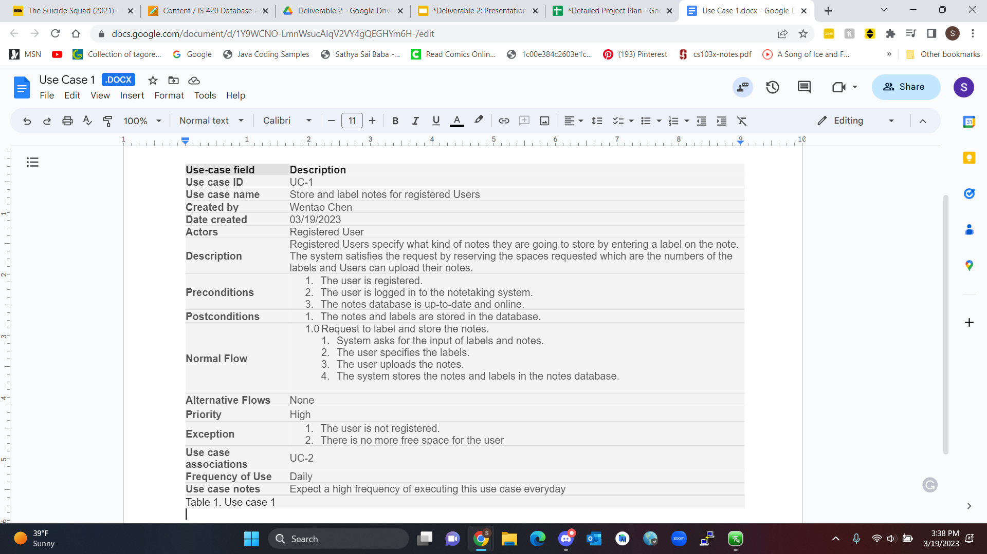

Use Case 1 - Diagram

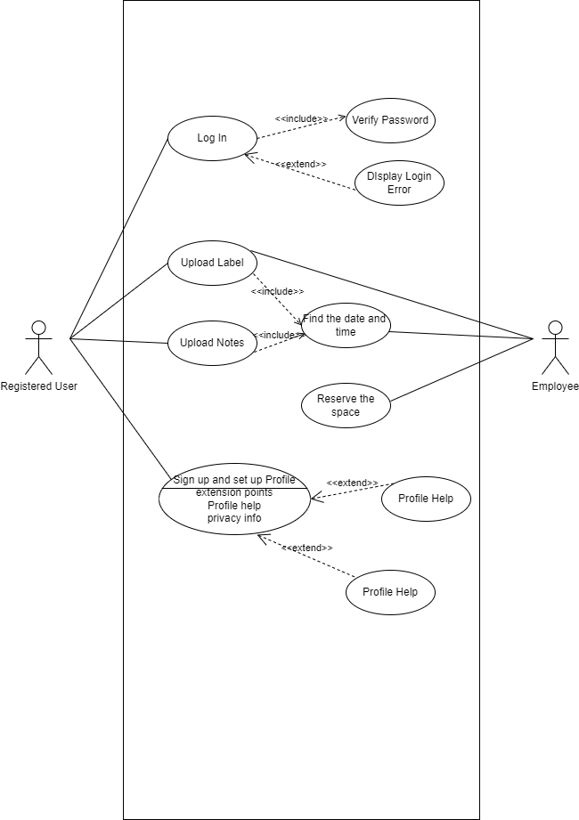

Use Case 2

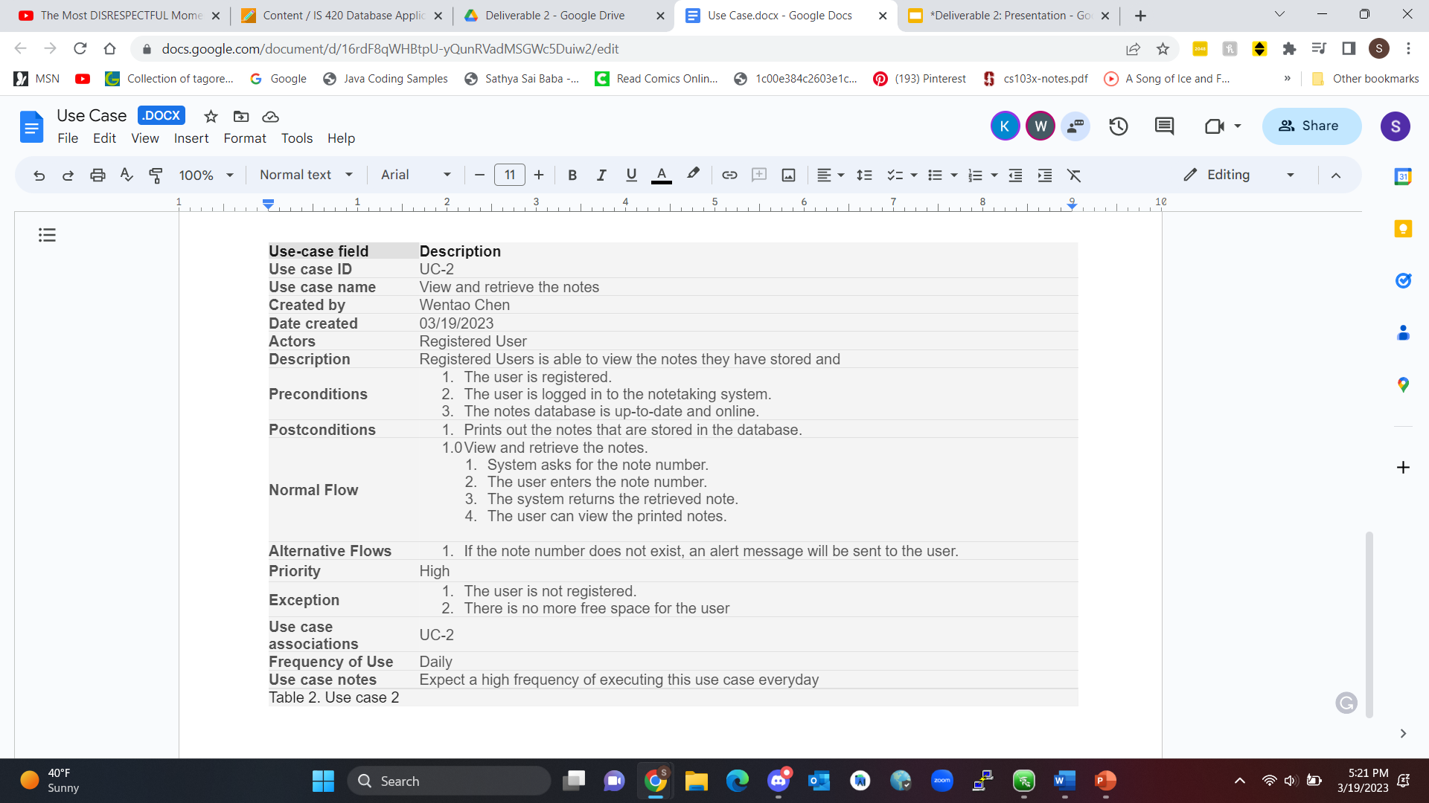

Use Case 2 - Diagram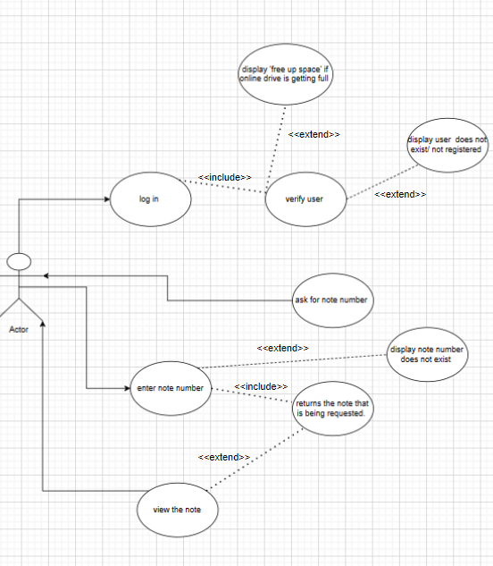

Detailed Project Plan

| Tasks | Responsible | Start | End | Days | Status | Timeline |
| --- | --- | --- | --- | --- | --- | --- |
| **3/19/2023** |  |  |  |  |  |  |
| Deliverable 2 |  | 3/5 | 3/19 | 14 | **Complete** | 3/5 - 3/14 |
| Agree on objectives |  | 10-Mar | 19-Mar | 9 | **Complete** | 3/10 - 3/19 |
| **Initiation** |  |  |  |  |  |  |
| Detailed Reqs. | Kristen J. | 5-Mar | 9-Mar | 4 | **Complete** | 3/5 - 3/9 |
| Hardware Reqs. | Wentao C. | 5-Mar | 10-Mar | 5 | **Complete** | 3/5 - 3/10 |
| Final Resource Plan | Soham A. | 5-Mar | 7-Mar | 2 | **Complete** | 3/5 - 3/7 |
| Staffing | Kimberly H. | 5-Mar | 6-Mar | 1 | **Complete** | 3/5 - 3/6 |
| **Development** |  |  |  |  |  |  |
| Technical Reqs. | Paul R. | 5-Mar | **-** | **-** | **In progress** | 3/5 - 3/9, 3/20 - 3/24 |
| DB Development | Wentao C. | 5-Mar | **-** | **-** | **In progress** | 3/5 - 3/12, 3/24 - 3/26 |
| API Development | Soham A. | 5-Mar | **-** | **-** | **In progress** | 3/5 - 3/13, 3/26 - 3/28 |
| UI Client | Catherine V. | **-** | **-** | **-** | **Not started** | 3/28 - 4/1 |
| Testing | Kristen J. | **-** | **-** | **-** | **Not started** | 4/1 - 4/4 |
| Dev. Complete | Kimberly H. | **-** | **-** | **-** | **Not started** | 4/4 - 4/7 |
| **Operations** |  |  |  |  |  |  |
| Hardware Config. | Wentao C. / Soham A. | **-** | **-** | **-** | **Not started** | 4/7 - 4/9 |
| System Testing | Kimberly H. / Kristen J. | **-** | **-** | **-** | **Not started** | 4/9 - 4/11 |
| **Launch** |  |  |  |  |  |  |

Team Information

Team Name: Note Taking Website

Project Contact Information: [kho6@umbc.edu](mailto:kho6@umbc.edu)

Time set aside to meet outside of class:

* Thursday (3/13/23): 6 - 7 PM
* Friday (3/17/23): 4 - 5 PM
* Saturday (3/18/23): 3 - 4 PM
* Sunday (3/19/23): 2 - 4 PM

Team Members:

**Soham Adhikary:** Research Analyst

[sadhika2@umbc.edu](mailto:sadhika2@umbc.edu)

“I am an IS Major with a minor in Computer Science. I am looking forward to applying what I've learned into the real world.”

**Kimberly Ho:** Data Analyst - Created Questionnaire, Interviews, Presentation

kho6@umbc.edu

“My name is Kimberly and I am an Information Systems major. I hope to apply what I learn to find a career related to my major.”

**Wentao Chen:** Business Analyst - Requirements definition and assisted in use case analysis

[wentaochen@umbc.edu](mailto:wentaochen@umbc.edu)

“I am Wentao and I major in Information Systems. I would like to go to graduate school after I graduate from UMBC.”

**Kristen Jones:** Project Management - Editor and created due dates and timeline, assist with diagrams

[kjones24@umbc.edu](mailto:kjones24@umbc.edu)

“My name is Kristen and I’m majoring in information systems and plan on working while going to school in the near future.”

**Paul Rajapandi:** Team Member

[gauthar1@umbc.edu](mailto:gauthar1@umbc.edu)

“My name is Paul, I’m an information systems major, I hope to be working in the field after I graduate.”

**Catherine Vargas:** Team Member

[cvargas1@umbc.edu](mailto:cvargas1@umbc.edu)

“My name is Catherine and I am majoring in information systems. After I graduate I hope to find a job in my field that is maybe related to project management.”

GitHub Link:

<https://github.com/WentaoChen1/IS-436>